Te Kaahui Ako o Mangakootukutuku
A collaborative community of learning and teaching across South West Hamilton

Achievement Challenge

May 16, 2018
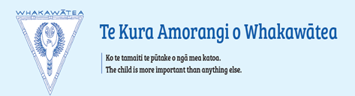
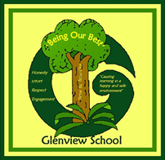
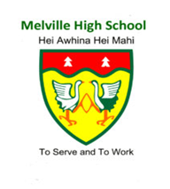
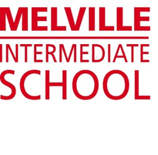
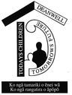

Contents

1. Our Vision 1
2. Our Focus 1
3. Our Principles and Values 1
4. Introducing our Community 2
5. Introducing Te Kaahui Ako o Mangakootukutuku 3
6. Engaging our Community 5
7. Education Review Office Community of Learning Report: December 2016 6
8. Our Students’ Progress and Achievement: Data We Have 7
9. The Data Targets We Have Set: 2017–2019 14
10. Our Achievement Challenges 15
11. Monitoring and Tracking the Progress of our Kaahui Ako 22

1. Our Vision

Empowering Achievement | Nurturing Great People
Whakamana te Tuutukitanga a te Tangata
Empowering students, whaanau, families, staff and community in creating and sustaining partnerships focused on progress and achievement for our students.

2. Our Focus
- Students having a shared responsibility in their own learning
- Whaanau engagement that is sustained and educationally powerful
- Raising teacher and leadership capability and capacity

3. Our Principles and Values
- Commitment to co-operate and collaborate to achieve our collective goals
- Demonstration of trust, confidentiality, honesty, openness and respect
- Communication which is open, effective and professional
- Respect for the importance of ako in our professional relationships
- Clear statement of issues and challenges
- Unrelenting focus on raising learner achievement throughout their learning pathway
- Acknowledgment of mana whenua, ensuring their inclusion in decision-making and the recognition of their aspirations
- Performance of all assigned responsibilities in a timely manner

4. Introducing our Community
West Hamilton, south of Waikato Hospital, developed rapidly in the 1960s and 70s as a strong suburban growth area. Melville Primary School had served the area for many years prior but the other schools date from this growth period.
The demographics of age and socio economic composition since the 1970s have produced a series of cycles which have seen periods of growth and decline in school rolls. Our schools serve the census area made up of Bader, Melville, Glenview and Peacocke. This area had a total population of 14,415 in 2013 and according to the 2013 census had a population growth of less than 1% over the period 2007 to 2013.

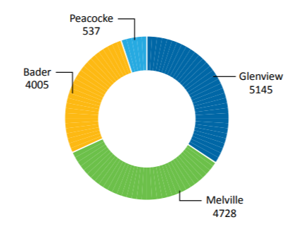
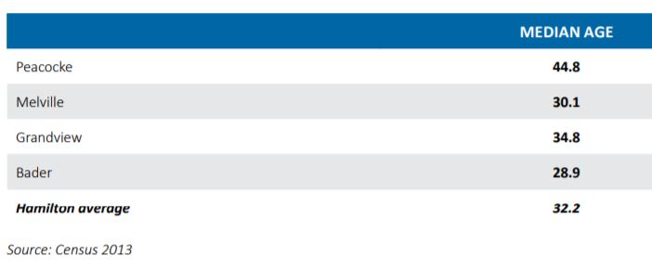

In addition to this area, our Kaahui Ako incorporates Koromatua School, a rural school 5km south west from the city boundary.
The proportion of Maaori across the population of Hamilton identified in the census of 2013 was 21%. The proportion identified as Maaori in the census area of Melville, Bader, Glenview and Peacocke was 23%. In 2016 the proportion of Maaori students attending the schools in our Kaahui Ako was 56%.
In 2015, Hamilton City Council produced a series of city wide community profiles based on 2013 census data. This population data describes a significant level of social diversity within the geographic area of our Kaahui Ako. This provides opportunities for us to use a range of customised strategies to address the learning needs of the students in our community.
Our community is hardworking, families and whaanau have high expectations for their children and tamariki. Our largest single employer, Waikato Hospital has over 6,000 employees. In 2017 the rate of house sales ranked 4th in Hamilton City and in 2016 according to a NZ Herald survey, Melville ranked first nationally in the rate of returns on investment for rental properties. Infrastructure development worth $250million is planned and scheduled by Hamilton City Council.
Early Childhood Education Centres (ECE) are a strong feature of this community with over 50 Centres contributing children to our Kaahui Ako primary schools. Almost 25% of the population is under 15.

5. Introducing Te Kaahui Ako o Mangakootukutuku
In August 2015 the Board Chairs and Principals from nine of our local schools began a series of meetings to discuss collaboration focused on student progress and achievement.
Early in 2016 three Boards signed “Expressions of Interest” to form a Community of Learning. Meetings of Principals continued to explore common areas of challenge and concern. All local schools have continued to have an open invitation to attend these meetings. By mid-2016 the Boards of six schools had formally joined our Community of Learning.
We invited the Education Review Office in July 2016 to present a report on our Community of Learning to a meeting of all local Principals.
We had also invited NZSTA to make a presentation in November 2016 to the Boards of Schools in our Community of Learning on Boards’ responsibilities with respect to student progress and achievement. Principals met regularly through 2016 reviewing student achievement data. Issues raised included the validity and reliability of some data, the consistency of approach between schools and the areas of learning that could be identified as challenges.
By the end of 2016 the Principals’ group had identified draft achievement challenges and proposed a structure to formalise the involvement of Boards of Trustees and community representatives in the governance and management of our Community of Learning.
The Stewardship group met for the first time in March 2017. That meeting endorsed the vision, the focus and the principles that would guide our Kaahui Ako forward. David Cooke, Principal of Melville Intermediate School was appointed as Leader from 1st May 2017.
The name of our Community of Learning was confirmed as Te Kaahui Ako o Mangakootukutuku.
Our vision statement “Empowering students, whaanau, families, staff and community in creating and sustaining partnerships focused on progress and achievement for our students” indicates the importance of close liaison with partners both within and beyond our community. Our High Level Plan and our forthcoming Implementation Plans indicate this importance.

Location of the Schools in our Kaahui Ako

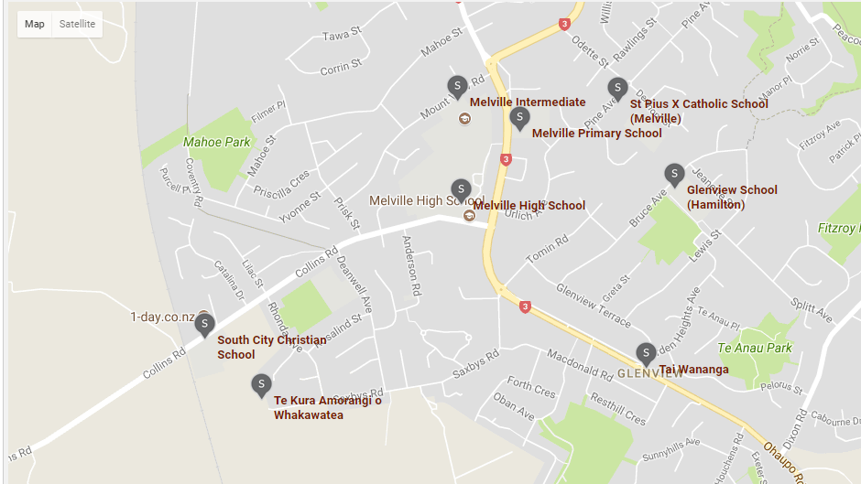

Deanwell Primary School
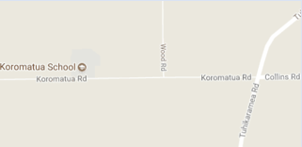

Schools in our Kaahui Ako

Schools | MoE | Decile | Roll  July 2017 | Māori | Pasifika | Asian | Euro | Status
Deanwell School | 1710 | 3 | 405 | 57% | 10% | 8% | 24% | Yrs 1–6
Glenview School | 1725 | 5 | 438 | 33% | 5% | 9% | 52% | Yrs 1–6
Koromatua School | 1784 | 6 | 155 | 85% | 8% | 2% | 4% | Yrs 1–8
Melville High School | 137 | 4 | 584 | 50% | 5% | 11% | 30% | Yrs 9–13
Melville Intermediate School | 1823 | 3 | 236 | 58% | 9% | 5.5% | 25% | Yrs 7–8
Melville Primary School | 1824 | 2 | 170 | 76% | 8% | 3.5% | 10% | Yrs 1–6
Te Kura Amorangi  o Whakawātea | 282 | 4 | 132 | 96% | 1% | - | 3% | Yrs 1–8
Totals |  |  | 2148 | 57% | 6% | 6.5% | 21%

6. Engaging our Community
Our partnership with iwi embraces a shared goal of raising Maaori learner success.
Both Ngaati Wairere and Ngaati Maahanga are identified as mana whenua. Schools have made the connections identified by their own kaumatua. ERO have identified that our schools each have kaumatua providing advice and guidance for promoting Tainuitanga.
A strong drive in each of our schools has been on creating strong, positive connections with parents, whaanau and community. Collectively we have committed to this as an important focus area for our Kaahui Ako. All schools in our Kaahui Ako are committed to further develop culturally responsive pedagogies and models to support strengthening whaanau engagement and student achievement. Our partnership with iwi will further support whaanau to confidently engage in the education of their tamariki.
In 2017 Melville High School signed a Memorandum of Understanding with Waikato Tainui as part of the Kawenata o te Mana Maatauranga, establishing a commitment to work together in achieving mutual educational objectives. All of our Kaahui Ako schools are kept up to date on developments. We have requested that our Kaahui Ako be considered to be part of any Kawenata Primary School trial.
A number of our schools are members of the Waikato Maaori Achievement Collective which is committed to raising Maaori student achievement.
Schools in our Kaahui Ako have amended their strategic planning (Charter) to align with the Waikato Tainui Education Strategic Plan.
Formal approaches have been made to Waikato-Tainui , Ngaati Raukawa, Ngaati Hauaa and Ngaati Maniopoto with an invitation to endorse our Achievement Challenge. A formal meeting was held in February 2018 with a Waikato-Tainui Education Manager to broadly plan the steps of iwi consultation. As a result we have established iwi representation on our Kaahui Ako Stewardship (governance) Group. Consultation and engagement will continue to encourage strong connections with other iwi.

Early Childhood Sector
There are 17 early childhood centres within our community and another 40 outside our community that are currently contributing centres to our primary schools. Once the Achievement Challenge is endorsed we intend to invite the early childhood centres to nominate representatives to be part of our ongoing development. Those centres with whom we have already met are aware of this process. There has been discussion over the inclusion of “oral language development” as an achievement challenge that can initially focus our work with the EC sector. Preliminary discussions have already raised the issue of resourcing required for closer liaison. We have used Te Whaariki as a foundation document from which we developed our philosophy.

Corporate and Tertiary Sectors
There are already very strong links between our High School and Waikato business interests, Wintec, the University of Waikato and Te Waananga o Aotearoa. We will develop those links to extend our learners’ pathways into the tertiary sector.

7. Education Review Office Community of Learning Report: December 2016
This report, based on data from the five schools then in Te Kaahui Ako o Mangakootukutuku is an independent statement of strengths and challenges. Since that time another two schools, Deanwell School and Glenview School, have joined the Kaahui Ako.
“Publicly available student achievement information across the CoL shows that about 67% of the students in Years 1 to 8 were achieving at or above the National Standards in reading, writing and mathematics in 2014. Girls are achieving better than boys in these curriculum areas. The achievement of Māori is similar to non-Māori in reading, writing and mathematics. In Te Kura Amorangi o Whakawātea, achievement information identifies the majority of students are achieving above their expected levels for pānui, tuhituhi, kōrero and pāngarau.
The 2014 NCEA data for the secondary school indicated that of the students who left school in 2014, 70.8% of school leavers had attained NCEA Level 2 or above. The CoL has a challenge to reach the Better Public Service (BPS) target of 85% of students leaving school with NCEA Level 2.”
“Common strengths include:
- trustees commitment to providing effective governance and strategic direction for ongoing school improvement
- collegial leadership that is reflective and focused on raising student achievement
- a specific focus on improving students’ skills in reading, writing and mathematics
- students experiencing success in a range of academic, sporting, cultural and artistic activities
- supportive and inclusive learning environments that promote student wellbeing
- a commitment to promoting and sustaining productive and collaborative relationships among trustees, students, parents, whānau and the wider community
- trustees in the kura use student achievement information as the basis for decision making about student learning.”
“Areas for improvement include:
- developing a strategic approach to achieving the expectation of 85% of students reaching the BPS target by 2017
- supporting students to understand and take more ownership of their learning
- continuing to develop and strengthen partnerships with local iwi to enhance the Maaori perspective in the schools' curricula
- strengthening the interpretation and use of achievement data to inform self-review
- more rigour and accountability to accelerate student achievement and aligning this process to teacher inquiry and teacher appraisal
- improving outcomes for students at risk of not achieving, particularly, Māori, Pacific and boys
- reviewing transition processes between early childhood services, primary and secondary schools.”

8. Our Students’ Progress and Achievement: Data We Have

A: National Standards Achievement Data 2012–2016
Kaahui Ako o Mangakootukutuku, aggregated data. Percentage ‘’At’’ and “Above” National Standards

Writing
Deanwell School
Glenview School
Koromatua School
Melville Intermediate School
Melville Primary School
Te Kura Amorangi o Whakawātea
Writing | 2013 | 2014 | 2015 | 2016
After 1 Year | 73.3% | 69.6% | 61.5% | 61.7%
After 2 Years | 72.1% | 67.6% | 70.3% | 59.8%
After 3 Years | 54.4% | 66.7% | 68.4% | 62.1%
End of Year 4 | 57.5% | 54.7% | 60.6% | 60.8%
End of Year 5 | 47.1% | 52.1% | 52.4% | 63.7%
End of Year 6 | 55.4% | 55.1% | 56.0% | 55.1%
End of Year 7 | 62.0% | 63.5% | 66.2% | 57.9%
End of Year 8 | 69.8% | 68.8% | 71.7% | 62.2%

Writing | 2012 | 2013 | 2014 | 2015 | 2016
Māori | 56.2% | 59.4% | 61.8% | 62.3% | 56.2%
Pasifika | 62.9% | 56.6% | 62.4% | 72.8% | 70.4%
European | n/a | 64.6% | 61.5% | 61.0% | 65.4%
Female | 68.3% | 72.0% | 71.9% | 69.3% | 68.7%
Male | 50.2% | 51.8% | 52.7% | 57.4% | 52.9%
CoL Total | 58.9% | 61.6% | 62.1% | 63.1% | 60.5%

Writing: Year 10 - 2017
Total Year 10 | Well Below  e-asTTLe: 3, 2 | Below  e-asTTLe: 4a, 4P, 4B | At  e-asTTLe: 5B, 5P | Above  e-asTTLe: 5A | Target All
119 | 59 | 50 | 9 | 1 | 50
Māori | Well Below  e-asTTLe: 3, 2 | Below  e-asTTLe: 4a, 4P, 4B | At  e-asTTLe: 5B, 5P | Above  e-asTTLe: 5A | Target Māori
60  M= 30  F = 30 | 30  M = 17  F = 13 | 24  M = 12  F = 12 | 5  M = 1  F = 4 | 1  M = 0  F = 1 | 24  M = 12  F = 12

Analysis
- Teachers assessment of girls is far higher than for boys (possibility of bias).
- Well below the target of 85% or even national average of 72%.
- Range of 55–64% in 2016.
- OTJs at Y1 and Y8 are comparable – 62% at or above.
- Lots of PD in written language over five years with no noticeable improvement in achievement.
- Effects are not sustained.
- Year 10 data as measured by e-asTTle as opposed to National Standards as used by primary schools, suggests a possible lack of consistency between modes of assessment.

So what now?
- Identify the issues that are contributing to a lack of progress in writing.
- The value of recent PLD is not apparent. We need to undertake a new approach to PLD based on action research, identified needs, learning progressions and learner engagement.
- Undertaking cross-school scans appears to be an important strategy to identify next steps. This could be the first task of cross-school and in-school lead teachers.

Reading
Reading | 2013 | 2014 | 2015 | 2016
After 1 Year | 56.7% | 59.6% | 55.6% | 54.4%
After 2 Years | 83.8% | 70.5% | 77.2% | 62.6%
After 3 Years | 77.4% | 82.4% | 78.1% | 81.0%
End of Year 4 | 77.6% | 77.9% | 73.4% | 80.1%
End of Year 5 | 72.4% | 67.5% | 68.2% | 74.1%
End of Year 6 | 86.7% | 77.8% | 78.0% | 70.5%
End of Year 7 | 69.7% | 73.0% | 73.8% | 73.7%
End of Year 8 | 75.6% | 73.0% | 84.8% | 80.0%

Reading | 2012 | 2013 | 2014 | 2015 | 2016
Māori | 70.2% | 74.6% | 71.9% | 72.8% | 69.1%
Pasifika | 65.7% | 73.7% | 73.1% | 77.2% | 79.6%
European | n/a | 77.0% | 73.7% | 73.3% | 74.9%
Female | 76.6% | 79.3% | 77.0% | 77.0% | 77.6%
Male | 66.9% | 71.8% | 68.3% | 70.2% | 69.1%
CoL Total | 71.6% | 75.4% | 72.6% | 73.5% | 71.6%

Analysis
- Reading achievement is higher than Maths achievement.
- Y1 achievement is low – in 50% range however trend over time shows marked improvement.
- Girls and boys results differences are significant – about 8%.
- 2016 European versus Maaori gap increased.
- End Year 6 data at or above 70.5%.
- Data outcomes improve over time at school.
- Results across cohorts are reasonably static over time.
- Range across cohorts is significant 56%–81%.

So what now?
While results in Reading have much room for improvement they are considerably better than those for Written Language and thus will not be an immediate area of priority for this Kaahui Ako.

Mathematics
Mathematics | 2013 | 2014 | 2015 | 2016
After 1 Year | 82.7% | 74.3% | 79.5% | 70.6%
After 2 Years | 70.5% | 60.2% | 74.1% | 62.0%
After 3 Years | 62.6% | 64.1% | 69.0% | 71.2%
End of Year 4 | 62.6% | 62.2% | 66.0% | 72.9%
End of Year 5 | 48.8% | 53.8% | 63.5% | 74.1%
End of Year 6 | 65.1% | 59.9% | 73.8% | 67.0%
End of Year 7 | 58.5% | 65.0% | 56.2% | 51.1%
End of Year 8 | 68.0% | 70.0% | 69.7% | 64.4%

Mathematics | 2012 | 2013 | 2014 | 2015 | 2016
Māori | 64.0% | 63.5% | 61.6% | 68.6% | 62.7%
Pasifika | 59.0% | 64.6% | 60.2% | 66.3% | 70.4%
European | n/a | 65.8% | 67.2% | 68.6% | 72.2%
Female | 63.3% | 67.8% | 64.4% | 68.8% | 68.0%
Male | 65.5% | 62.1% | 62.6% | 69.7% | 66.6%
CoL Total | 64.4% | 64.8% | 63.5% | 69.3% | 67.3%

Analysis
- Pasifika data shows better outcomes than for Maaori.
- No significant change in results over five years.
- Year 6–7 data drops as a cohort.
- 2016 67% are at the standard by the end of Year 6.
- 64% are at the standard by the end of Year 5.
- Greater differentiation of results by ethnicity and gender is evident in 2016.
- In the Year 7 cohort 51% are achieving the standard and in the Year 5 cohort 74% are achieving the standard. The range between the two cohorts is concerning.

So what now?
The data as presented raises issues relating to the reliability and validity of the data. We have undertaken to develop greater consistency and comparability across schools in measuring progress and achievement in Mathematics. PaCT has been considered as a means of achieving consistency with respect to curriculum levels.

B: NCEA Melville High School 2013–2017
Data is roll-based, percentage achieved.
Academic year | Year 11  NCEA Level 1 |  |  | Year 12  NCEA Level 2 |  |  | Year 13  NCEA Level 3
 | Melville High | National | Decile 4–7 | Melville High | National | Decile 4–7 | Melville High | National | Decile 4–7
2013 | 58.5 | 70.6 | 72.1 | 63.3 | 71.6 | 73.8 | 31.5 | 57.6 | 55.9
2014 | 69.3 | 72.5 | 74.6 | 69.8 | 75.4 | 77.6 | 40.0 | 60.2 | 57.9
2015 | 62.7 | 74.4 | 76.5 | 81.3 | 76.4 | 78.9 | 58.1 | 62.7 | 61.9
2016 | 55.9 | 75.5 | 78.0 | 79.6 | 78.4 | 80.8 | 65.3 | 64.5 | 63.1
2017 | 57 | 72.9 | 75.7 | 77.7 | 77.2 | 79.8 | 55.8 | 64.2 | 63
Maaori | 41.4 | 73.4 | 66.3 | 72.2 | 77.6 | 76.1 | 42.9 | 64.8 | 57.1

Analysis
- Level 1 results are relatively consistent over time and they are, on average, significantly less than decile 4 to 7 results.
- Level 2 and Level 3 results more closely match national averages for decile 4 to 7.
- The low pass rate in NCEA Level 1 has an effect on numbers of students able to achieve at Levels 2 and 3. This may also be impacting retention of students into Years 12 and 13.
- Maaori students have signficantly poorer performance at Level 1 than all other students.

NCEA cumulative results in literacy by percentage
Academic year | Year 11  NCEA Level 1 |  |  | Year 12  NCEA Level 2 |  |  | Year 13  NCEA Level 3
 | Melville High | National | Decile 4–7 | Melville High | National | Decile 4–7 | Melville High | National | Decile 4–7
2013 | 71.9 | 89.9 | 90.1 | 92.3 | 94.6 | 95.4 | 93.8 | 95.6 | 95.7
2014 | 82.2 | 91.3 | 92.0 | 92.6 | 95.4 | 96.1 | 92.9 | 96.0 | 96.2
2015 | 81.6 | 91.3 | 91.9 | 90.4 | 95.3 | 95.6 | 98.6 | 96.2 | 96.6
2016 | 79.5 | 91.4 | 92.1 | 93.4 | 95.9 | 96.5 | 97.8 | 96.5 | 96.7
2017 | 84.1 | 91.2 | 92.2 | 94.7 | 95.8 | 96.4 | 95.7 | 96.3 | 96.5
2017  Maaori | 74.1 | 85.7 | 88.2 | 95.1 | 95.4 | 96.6 | 94.6 | 97.7 | 98.3

NCEA cumulative results in numeracy by percentage
Academic year | Year 11  NCEA Level 1 |  |  | Year 12  NCEA Level 2 |  |  | Year 13  NCEA Level 3
 | Melville High | National | Decile 4–7 | Melville High | National | Decile 4–7 | Melville High | National | Decile 4–7
2013 | 79.3 | 87.3 | 87.8 | 94.0 | 93.3 | 94.2 | 93.8 | 95.3 | 95.5
2014 | 86.7 | 89.3 | 90.6 | 93.7 | 94.4 | 95.5 | 96.4 | 95.2 | 95.6
2015 | 87.5 | 89.9 | 90.7 | 94.4 | 94.5 | 95.2 | 100.0 | 95.6 | 96.3
2016 | 82.2 | 90.1 | 91.2 | 95.9 | 95.2 | 96.0 | 98.9 | 96.0 | 96.5
2017 | 85.1 | 89.8 | 91.1 | 94.7 | 95.0 | 96.1 | 96.8 | 95.8 | 96.3
2017  Maaori | 77.6 | 82.7 | 85.5 | 93.4 | 94.2 | 95.5 | 97.3 | 97.1 | 98.0

Analysis
At Year 11 the attainment level of both numeracy and literacy credits is significantly less than national and decile averages.

So what now?
These data suggest that targeting literacy and numeracy credits in Level 1 NCEA is the critical first step to achieving better NCEA results. There is a deliberate attempt to address Maaori achievement for this cohort and is reflected in the High School’s plan of action.

C: Attendance Data: Te Kaahui Ako o Mangakootukutuku
Data presented by Lisa Rogers, Deputy Secretary, Ministry of Education 2015.
Probabililty of achieving literacy and numeracy credits based on attendance and lateness in year 8
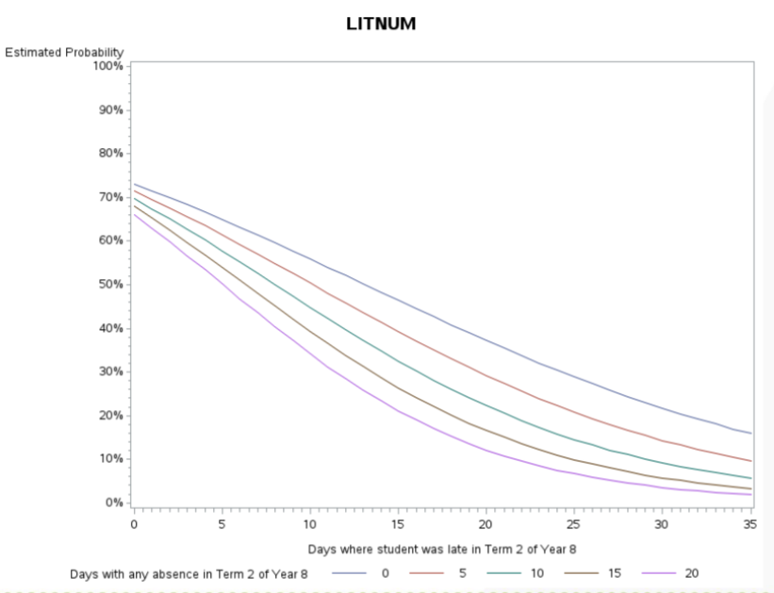
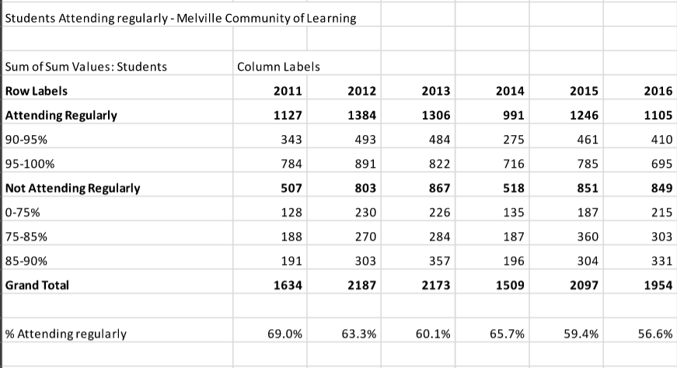
Source: Ministry of Education 2017
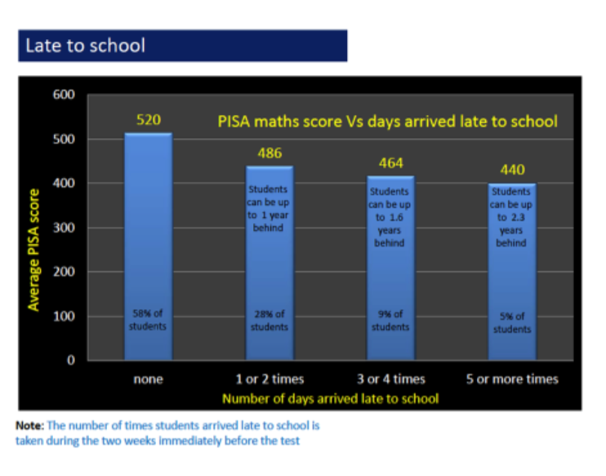

Analysis
Data indicates that about half of the students attend school regularly (90% or more).

So What Now?
- We know that regular attendance and punctuality to class are both predictive of achievement at NCEA Levels 1 and 2. For Year 11 students there is a positive statistical relationship between attending school and the probability of achieving NCEA Level 1. Research has shown that this relationship also exists in attendance data in the years prior to Year 11.
- Regular attendance and punctuality are community wide issues that affect every school and are a priority for collective action through our Kaahui Ako if results are to improve. Collecting data will be part of the collective action plan and responding to that data will be prioritised in our Implementation Plan.
- We will develop protocols around attendance data sharing and analysis between schools.

Transience
Transience is defined by the Ministry of Education as students who move school twice or more during the period between 1st March and 1st November in any year. Ministry statistics are based on this indicator. The national rate for transient students has remained at 5 per 1,000 students over the last 5 years. There is significant variation across national decile data. The rate for Hamilton City is 13 students per 1,000.
Our Kaahui Ako has identified the numbers of students entering our school during the school year after March 1st as a potentially destabilising factor both for incoming students and for current students. So that we can monitor and ameliorate this concern we have redefined “transience” in our situation to refer to students who move into our schools after March 1st each year. Our data from 2017 and 2018 indicates the average rate of transience in our Kaahui Ako is significant.
Existing data does show that there are concerning correlations between transience, however it is defined, and barriers to achievement. Our Kaahui Ako schools generally have an acknowledged challenge around transience and the issues that it brings. As a Kaahui Ako we are collecting and analysing data that describes those correlations and planning how to minimise and mitigate the negative impact on some students who meet the definition of transience.
The experiences of the schools in our Kaahui Ako indicate that even a single move into a school after the beginning of the year can be accompanied by negative impacts. Building a robust pathway of learning for our students will require our schools to react positively to transience and transitions within our Kaahui Ako.

Transients per 1,000 enrolled students by decile (2016)

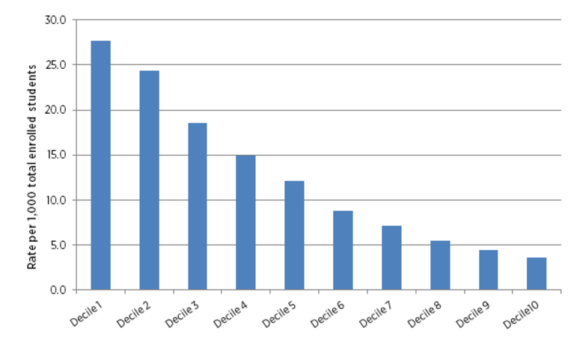

So what now?
We plan to react strategically to enrolments after the start of the year by strengthening transition and induction protocols and plans for incoming students. We will ensure that detailed learning pathway data accompanies leaving students.

9. The Data Targets We Have Set: 2017–2019

Melville High School

A: Literacy targets for Year 10, NCEA Level 1, 2017–2019
 | 2016 (actual) | 2017 (actual) |  | Target 2018 |  | Target 2019
 |  | Percentage | Number | Percentage | Number | Percentage | Number
Year 10 Writing  - Level 5 |  |  | 154 |  | 115
Literacy Level 1 | 79.5% (87) | 84.1% | 94/111 | 100% | 154/154 | 100% | 115/115
NCEA Level 1 | 55.9% (61) | 57.0% | 63/111 | 75.0% | 115/154 | 80.0% | 92/115

B: Literacy targets for written language Years 1–8, 2018–2020
The target group has been identified as the number of students who were graded “below expectation in Writing” at the end of 2017.

Targets for 2019 to 2020 will focus on actual students performing below expected curriculum levels.
Number of students required to meet Year 1 to 8 WRITING Achievement Targets by the end of 2019
Years 1–8  School Name |  | Total Boys Below (2017) | Total Girls Below (2017) | Total Target Students 2018 | Māori Boys Below (2017) | Māori Girls Below (2017) | Total Target Māori  2018
Melville Primary School | Year 1 | 10 | 8 | 3 | 10 | 8 | 3
 | Years 2–6 | 73 | 70 | 36 | 59 | 52 | 35
Koromatua School | Year 1 | 10 | 14 | 24 | 7 | 11 | 18
 | Years 2–8 | 29 | 22 | 51 | 26 | 18 | 44
Glenview School | Year 1 | 8 | 5 | 13 | 4 | 2 | 6
 | Years 2–6 | 52 | 36 | 88 | 19 | 16 | 35
Deanwell Primary School | Year 1 | 11 | 11 | 22 | 9 | 7 | 16
 | Years 2–6 | 70 | 60 | 130 | 45 | 37 | 82
Melville Intermediate | Years 7–8 | 34 | 24 | 58 | 20 | 15 | 35
Total Year 1 |  |  |  | 62 |  |  | 43
Total Years 2–8 |  |  |  | 363 |  |  | 231
Total Students |  |  |  | 425 |  |  | 274
Number of Students “below” required to meet primary TUHITUHI Achievement Targets by 2019
Te Kura Amorangi o Whakawātea (2017) | Year 1 | 5 | 5 | 10 | 5 | 5 | 10
 | Years 2–8 | 8 | 8 | 10 | 8 | 2 | 10
Total roll 137
Total already “at and above” = 137
Total Students |  | 13 | 7 | 20 | 13 | 7 | 20

10. Our Achievement Challenges

Achievement Challenge One: NCEA Level 1

Our challenge: To have all Year 11 students achieve Level 1 and/or the goals set out in their aspirational plan.
Why we need to focus on this challenge.
- NCEA Level 1 roll-based results at Melville High School have averaged 59% over the last two years compared with a national decile band average of 77% over the same period.
- Level 2 and 3 results are closer to the national statistics but low levels of attainment at Level 1 are the major barrier to continued enrolment and success at school.
- Students come and go throughout the Year 11 academic year (retention).
- Some students struggle to attain the requisite literacy standards within that year.
- Students’ written language skills generally present a barrier to NCEA success.
- Entry level language skills at Year 9 as measured by e-asTTle Reading and Writing are below expectations.
- To ensure that students can access multiple learning and post-secondary pathways.
Our high-level plan of action for Achievement Challenge one is shown on the following page.

Our High-level Plan of Action for Achievement Challenge One
Student Achievement Targets
Goal: To improve NCEA Level 1 outcomes
Targets: - Improve NCEA 1 roll based levels to 80% by the end of 2018
- Improve Level 1 literacy to 100% by end of 2018
- Improve Level 1 numeracy to 100% by end of 2019
Key Strategies | Immediate Actions | Medium Term Actions  – by the end of 2018 | Longer Term Actions  – by the end of 2019
Whaanau engagement:  Create high expectation relationships that are reciprocal and respectful of students and families | Continue to focus on Academic Counselling and stress the importance of the gaining literacy credits and of enabling different pathway options.  Agree on what students, teachers and parents have to do to ensure these are gained. | Academic Counselling focuses explicitly on the partnership between the whaanau, the student and the school.  Collect Student Voice to determine student aspirations and strengths and use these to help forge a pathway towards success. | Academic Counselling continues. All aspects of school culture examined e.g., focus on student self-belief, own efforts to gain credits, and milestones of success at school.  May include success at extra-curricular activities as these have been shown to be instrumental in retention (Weinstein & Worrell, 2016) and the ability to go onto higher education.
Strategic leadership | Close monitoring of every student’s literacy credits and feedback to parents, students and all teachers of the students every term.  Ensuring accumulation of early credits for every student (terms one and two).  Leaders communicate the requirements of tertiary study to staff - annually.  Accessing appropriate learning support for students at risk. | Data on student credits is updated and shared with whaanau and students at least once per term.  Data on student progress (names, needs, next steps) is the focus of academic counselling and all school meetings (e.g., staff meetings; board meetings).  Academic Counselling strategies are shared with other schools - is this approach worth emulating at other levels? | Students are monitoring and reporting to academic counsellor on their own credit accumulation.
Raise capability of teachers and leaders  (See Teacher Capability and Oral Language plan for other targets in written language.) | Leaders communicate the need for every teacher to be a teacher of literacy – (how to write a good sentence and paragraph) and upskill for all.  (See Teacher Capability and Oral Language plan for other teacher and student focused strategies in written language.) | Teachers embed a consistent approach to paragraph writing in their subject areas.  Teachers focus on meta-cognitive skills (e.g., planning what to write; practising how to write in exams). | Teachers involved in PLD on high expectation schools.

Achievement Challenge Two: Teacher and Leadership Capability

Our challenge: To build teacher and leader capability – as measured by student progress in written language.
Why we need to focus on this challenge.
- Teacher and leadership capability underpins effective pedagogy and outcomes for students in all subjects. We have chosen to focus on outcomes in written language as a key area to measure progress as we are have concerns about progress in this area.

- All primary schools have engaged in extensive PLD on written language in recent years with little overall improvement in the data which is theorised as being due to:
  - the variability of the planning, teaching and assessment of writing
  - not enough emphasis on the purpose/engagement of writing
  - teacher enactment of the progressions
  - lack of accurate feedback and feed forward to students of highest needs
  - possible unconscious bias against Maaori/boys (e.g., research of Meissel et. al.)
  - insufficient self-regulatory strategies or student agency in their learning.

- To be sure that school leaders are:
  - differentiating between inquiry as compliance and inquiry as a mindset
  - providing time, structures and budget for teachers to inquire deeply into their practice and results
  - working on sustaining a strong whole school approach to written language
  - sustaining the good learning that has occurred through strong coaching and mentoring practices
  - setting high expectations of students and staff and sustaining progress from one stage to another
  - requiring teachers to focus on talking and writing every day, and having a strong purpose for it.

- To review progress to date across schools and formulate strategies to produce a significant change in teacher and student practice and progress.
  - Schools have engaged in written language PLD and Programmes for Students (PfS) to develop literacy.
  - Leaders have been asking teachers about what they do and why (revealing lack of knowledge of learning progressions).
  - Teacher inquiry into their effects on writing to be linked to appraisal of teacher effectiveness.

Our High-level Plan of Action for Achievement Challenge Two
Student Achievement Targets
Goal: Written language at Year 6, Year 8 and Year 10 will improve
Targets: That 100% of our target group will be writing at their expected curriculum level
Key Strategies | Immediate Actions | Medium Term Actions  – by the end of 2018 | Longer Term Actions  – by the end of 2019
Whaanau engagement;  Create high expectation relationships that are reciprocal and respectful of students/ families | Discuss what have we done in terms of whaanau engagement, and what next? | Plan how we are engaging whaanau in their child’s learning (e.g., face-to-face; electronic strategies; open days). Test strategies for effectiveness. | Enact a purposeful strategy of engagement.
Strategic leadership | Leaders will:  Inquire into what is working in their school in terms of students making progress (spirals of inquiry).  Plan to ensure that the approach to this wider plan is supportive of the well-being of teachers.  Adopt agreed expectations about how to teach and monitor written language and how teachers can inquire into their own effectiveness as teachers of written language.  Budget for PLD across schools to allow for joint PLD and moderation sessions (across schools and may focus on high expectations or other causal factors - not just written language). | Implement structural changes that positively impact teachers to be able to concentrate on doing less better.  Share the Melville High expectations of excellence at Level 1 as exemplar with contributing schools’ teachers.  Organise cross-school success days to share - what works and why. Sharing the ELP principles of effective practice.  Senior and middle leaders undertake own PLD on high expectation schools and consider implications for PLD for teachers at each school. | Leaders will:  Inquire into what is working in their school in terms of students making progress (spirals of inquiry).  Plan to ensure that the approach to this wider plan is supportive of the well-being of teachers.  Adopt agreed expectations about how to teach and monitor written language and how teachers can inquire into their own effectiveness as teachers of written language.  Budget for PLD across schools to allow for joint PLD and moderation sessions (across schools and may focus on high expectations or other causal factors - not just written language).
Raise capability of teachers and leaders | Leaders will set up procedures and practices to support teachers to consistently inquire into what is working and not working for students in writing for the 2018 year.  Leaders discuss their theories with teachers and engage in their own inquiries as to causes of written language problems. | Leaders and teachers engage in PLD on high expectation schools /learning mindsets and culturally responsive practices  Leaders plan changes to practices (e.g., grouping, student agency and school culture in readiness for 2019.  Consider the development of learning pathways in written language spanning stages of schooling. | Leaders jointly define what ‘best practice’ looks like in their schools and focus on these as employment criteria and as communication points to teachers and community.
Improve reliability of data | Leaders plan cross school moderation and joint teacher only day/s for the future.  Develop moderation patterns that build trust and confidence in the evidence and data we share. | Leaders plan and enact monitoring processes to ensure that this is making a difference - track students who stay at the school and those who are transient separately and seek acceleration effects for both groups. | Data is reviewed at school and Kaahui Ako level once per term to check for progress. Progress is reported back to teachers systematically and analysed for next steps.

Achievement Challenge Three: Embed Oral Language as the Foundation for Literacy

Our challenge: To embed oral language capability as the foundation for literacy for early learners.
Why we need to focus on this challenge.
- Oral language levels of capability are very low on entry to school with one school reporting 80% of students scoring 3 or less on Record of Oral Language (ROL) for Level 1.
- The low levels of formal and structured oral language means that transition to reading and writing can be challenging.
- We need to build and sustain expertise across learning pathways with schools and EC providers.

Our High-level Plan of Action for Achievement Challenge Three
Student Achievement Targets
Goals: Improve levels of vocab through observation survey data (written)
Improve levels of oral language – RoL at 6 years as compared to baseline at 5 years; and by comparing beginning and end of year data for Kaiako Reo in the kura
Targets: Increase on baseline data by 5% each year
Key Strategies | Immediate Actions | Medium Term Actions  – by the end of 2018 | Longer Term Actions  – by the end of 2019
Whaanau engagement:  Create high expectation relationships that are reciprocal and respectful of students and families | Suggestions / sessions for whaanau to implement at home. Focus on activities that grow vocabulary.  Engagement with early childhood continues with a focus on shared expectations about language development.  Gather Kaahui Ako-wide baseline data using ROL. | Leaders share with whaanau and teachers the importance of oral language and the impact it can have on overall literacy outcomes and success at school.  Develop opportunities to engage and work with ECE centres on oral language development.  Engage families and whaanau to support transitions into school. | Continue to build on sound, effective relationships and practices.
Strategic leadership | Kaahui Ako Leaders engage in PLD on high expectation schools.  Ensure that oral language is planned for and measured (ROL in English; Kaiaka Reo).  Leaders and teachers ensure that students have a voice in their learning and that they are included in the discussion of what and how to learn. | Decide on teaching (Learning through Talk) and tracking strategies.  Decide on the consistent approach that all schools adopt - for the empowered learner.  Monitor outcomes on oral language and vocabulary acquisition.  Track the levels of vocabulary acquisition. | Monitor outcomes on oral language and vocab acquisition.  Explore the extension of the oral language challenge across all levels of the learning pathway.
Teacher capability | Oral language activities are designed and planned for within literacy programmes and shared across our Kaahui Ako. | Teacher planning includes oral language and listening enrichment. | Teachers ensure that students are communicating effectively and appropriately with others at all levels.

Achievement Challenge Four: Attendance, Punctuality and Transience

Our challenge: To improve attendance and punctuality, and reduce the negative impacts of transience.
Why we need to focus on this challenge.
- Attendance is significantly below the national average and low attendance (along with lateness and transience) is highly correlated with achievement.
- It is an opportunity to set a strong foundation and expectations right from the Early Childhood level.
- For Year 11 students there is a clear positive statistical relationship between attending school and the probability of achieving NCEA Level.
- Research shows that this positive statistical relationship between attendance and achievement at Year 11 is also related to attendance and lateness in earlier years of schooling.
- Managing and mitigating the potentially negative effects of transience on students is required given the high levels of transience in the south west Hamilton area.

- Every school has identified student attendance and punctuality as an issue affecting outcomes. Causes of this may relate to:
  - this not being seen as a serious problem by students and families
  - habits - long established patterns
  - lack of strong community-wide support systems (e.g., The ROCK ON collaboration with Police has been discontinued as a community wide initiative)
  - lack of coherent approach to communication and response as a community.
Our high-level plan of action for achievement challenge four is shown on the following page.

Our High-level Plan of Action for Achievement Challenge Four
Student Achievement Targets
Goals: Improve levels of attendance and punctuality in order to improve learning outcomes
Targets: - By the end of 2018 attendance data will show average attendance rates to have improved by 5 percentage points over 2017data
- By the end of 2019 attendance data will show average attendance rates to have improved by 10 percentage points over 2018 data
Key Strategies | Immediate Actions | Medium Term Actions  – by the end of 2018 | Longer Term Actions  – by the end of 2019
Whaanau engagement:  Create high expectation relationships that are reciprocal and respectful of students and families | Investigate the reasons for lateness and absence across all schools.  Identify strategies immediately to support the learning and achievement of transient and transitioning students.  Students are better supported in their transitions across schools | Create a communication strategy to convey the importance of punctuality and attendance and the consequences of poor attendance and frequent lateness.  Implement the communication plan e.g., Regular and consistent across school communication in free newspapers; assemblies newsletters and electronic signage.  Investigate funding options to support this strategy.
Strategic leadership | Start communicating key messages/slogans to reinforce the goal. | Gather regular data on lateness and attendance and identify next steps.  Implement a strategy to deal with transient students e.g. planned induction into school.
 | Identify other community support services and initiatives and identify next steps to working together.  Plan for a consistent school year - dates and teacher only days. | Gather regular data on transience and identify next steps. Develop closer liaison between schools’ SENCO and prepare report on sharing SENCO resource across schools and whanau to mitigate negative effects of transition.
Collect sufficient data to establish a learning and achievement profile for arriving students.
Set and monitor realistic targets for individual “transient” students.

11. Monitoring and Tracking the Progress of our Kaahui Ako
Using the Ministry of Education Kaahui Ako Development Map we will review one domain each term and evaluate progress of our Kaahui Ako in the identified key areas.
Short term indicators will be developed to regularly monitor progress in key aspects of the Achievement Challenges.
For example:
- Close monitoring of literacy credits
- Close monitoring of attendance
- Close monitoring of students progress in writing paragraphs.
Progress will be reported to our Stewardship Group twice each year.
The four Achievement Challenge High Level Plans will be further developed into Implementation Plans which will be monitored and outcomes reported to the Community biannually.

